learn to curl clinic

Royal city curling club

sunday, september 13th, 2020

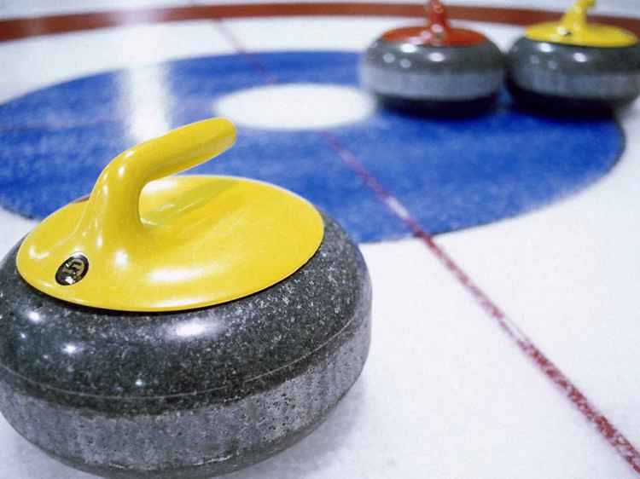 |  | Join us for a 2 hour introductory curling clinic.  Ideal for people with little or no curling experience.  Learn the basics in technique, rules, strategy and etiquette.  Or simply brush up on your skills…
$40.00 Novice (10 – 12 pm)

$25.00 Intermediate (12:30 – 1:30 pm)

Call 604-522-4737 or email
info@royalcitycc.com to reserve your space.

